Press Release

Domino Launches Gx-Series PRO to Help Manufacturers Prepare for the Next Era of 2D Coding
Gurugram, India – July 2026: Domino Printing Sciences has launched the new Gx-Series PRO thermal inkjet printhead, engineered to help manufacturers produce high-quality, GS1-compliant 2D codes at production-line speeds as packaging requirements continue to evolve.
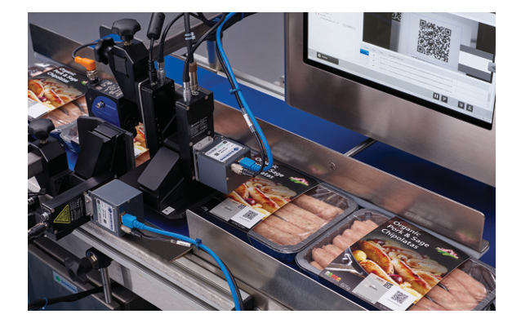
As global manufacturers prepare for the widespread adoption of GS1 Sunrise standards and increasing demand for QR and Data Matrix codes across retail and supply chains, Domino Printing Sciences has introduced the Gx-Series PRO—a next-generation thermal inkjet printhead engineered to simplify high-quality inline 2D code printing on modern production lines.
Designed for manufacturers operating in the food, beverage, FMCG, pharmaceutical and consumer goods sectors, the Gx-Series PRO helps producers generate high-resolution, GS1-compliant 2D codes at production speeds while supporting evolving requirements around product traceability, digital deposit return schemes, consumer engagement and regulatory compliance.
Unlike conventional coding systems, the Gx-Series PRO has been developed to deliver larger print areas, superior code contrast and reliable code grading across porous and non-porous substrates. With print resolutions of up to 1200 dpi, print speeds reaching 390 m/min, and support for up to four stitched printheads, manufacturers can produce high-quality variable-data codes without compromising production throughput.
The solution also supports reliable performance in chilled production environments through an optional printhead heater and offers food-packaging compliant inks manufactured in accordance with EuPIA Good Manufacturing Practices, making it well suited for demanding food production applications.
"Manufacturers are under increasing pressure to implement smarter packaging strategies while maintaining productivity and code quality," said Sachin Mall, Assistant Vice President – Products, Applications & Solutions, Domino Printech India. "The Gx-Series PRO has been developed to help producers confidently transition towards high-quality 2D coding, enabling compliance today while preparing for future digital packaging requirements."
The Gx-Series PRO is compatible with Domino's Gx150i, Gx350i and GxOEM platforms, enabling manufacturers to upgrade existing production environments while supporting larger print heights and multiple print positions from a single controller.
Media Contact:
Vasundhara Kohli
Assistant Manager – Marketing
Phone: +91 958 219 0929
Akash Kumar
General Manager – Marketing
Phone: +91 981 097 4683

