Press Release

Domino India celebrates 30 years of excellence with landmark employee summit in Jaipur
Gurugram, India – June 01, 2026
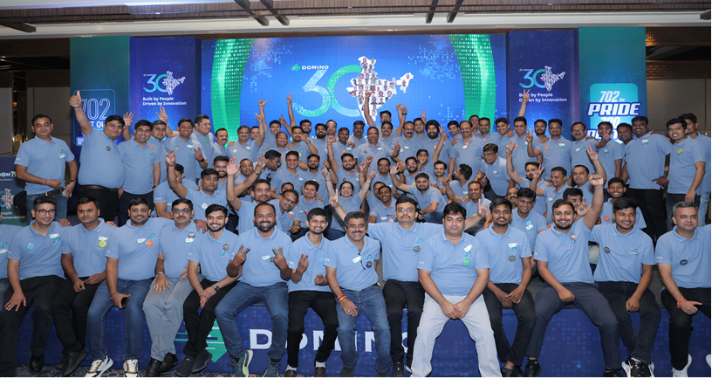
Marking a significant milestone in its journey, Domino India celebrated 30 years of operations in India with a landmark employee summit held at the Hyatt Regency Jaipur Mansarovar. Bringing together over 350 employees from across the country, the Five-day event stood as one of the largest and most impactful internal gatherings in the company’s history.
The celebration highlighted Domino India’s evolution into a trusted and leading provider of coding, marking and industrial printing solutions, built on a strong foundation of innovation, customer trust, and operational excellence. The milestone was further underscored by a strong financial performance in FY25, reflecting sustained growth and market leadership.
Designed as a platform to both celebrate and align, the summit brought together teams from diverse functions and regions to connect, collaborate, and collectively shape the path forward. The agenda featured a forward-looking blend of strategic business updates, digital transformation initiatives, AI-led innovation discussions, customer segmentation strategies, and product roadmap presentations tailored to the Indian market.
The summit also provided a preview of Domino India’s innovation roadmap for 2026, highlighting a new generation of coding and marking technologies designed to address the evolving needs of modern manufacturing. Among the solutions showcased were the Cx150i Oil high-resolution piezo inkjet printer, GX Pro industrial thermal inkjet coding and marking printer, Ux-360i UV laser coder, and the N-410 digital label press. The showcase highlighted the company's continued focus on innovation, connectivity, and delivering future-ready solutions for the manufacturing industry.
A key highlight of the event was the recognition of employee contributions through a series of awards and appreciation ceremonies, celebrating the people who have been instrumental in the company’s success. This was complemented by live product demonstrations, leadership development sessions, and team-building workshops led by external experts, reinforcing Domino India’s commitment to capability building and continuous growth.
The experience was further enriched through thoughtfully curated cultural engagements, offering attendees an immersive glimpse into Rajasthan’s rich heritage while fostering a strong sense of unity and shared purpose across teams.
Reflecting on the milestone, Tanuj Agrawal, Managing Director, Domino India, said:
“Completing 30 years in India is a proud and defining moment for all of us at Domino. Our journey has been shaped by the trust of our customers, the strength of our partnerships, and the dedication of our people – Built by People, Driven by Innovation. Achieving a stronger financial performance in FY25 is a significant milestone that reflects the collective effort of our teams across the country. As we move forward, we remain committed to driving innovation, embracing digital transformation, and delivering greater value to our customers. The energy and unity witnessed at this event truly reflect the strength of the One Domino India spirit.”
More than a celebration, the Jaipur summit reinforced Domino India’s continued focus on collaboration, innovation, employee engagement, and customer-centric growth. It also underscored the organization’s readiness to leverage emerging technologies and evolving market opportunities as it enters its next phase of growth.
As Domino India steps into its fourth decade, the focus remains clear; building on a strong foundation, empowering its people, and shaping the future with confidence, agility, and purpose.
Media contact:
Vasundhara Kohli
Assistant Manager – Marketing
Phone: +91 958 219 0929
Akash Kumar
General Manager – Marketing
Phone: +91 981 097 4683

